Detect the distance of object

# **Circuit diagram:**

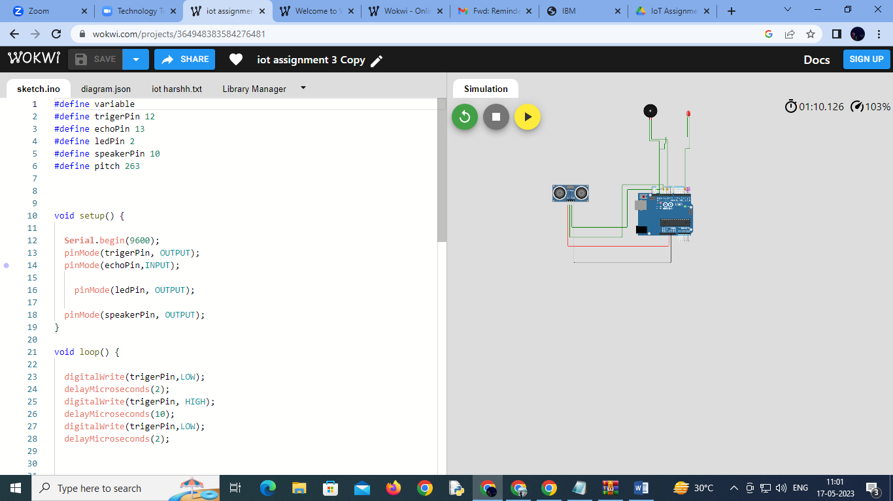

Source code:

#define variable

#define trigerPin 12

#define echoPin 13

#define ledPin 2

#define speakerPin 10

#define pitch 263

void setup() {

Serial.begin(9600);

pinMode(trigerPin, OUTPUT);

pinMode(echoPin,INPUT);

pinMode(ledPin, OUTPUT);

pinMode(speakerPin, OUTPUT);

}

void loop() {

digitalWrite(trigerPin,LOW);

delayMicroseconds(2);

digitalWrite(trigerPin, HIGH);

delayMicroseconds(10);

digitalWrite(trigerPin,LOW);

delayMicroseconds(2);

int Dur= pulseIn(echoPin,HIGH);

int Dis = (Dur/2)*0.0343;

if(Dis<100){

digitalWrite(ledPin,HIGH);

tone(speakerPin,pitch);

delay(300);

digitalWrite(ledPin,LOW);

noTone(speakerPin);

delay(300);

}

else{

digitalWrite(ledPin,LOW);

noTone(speakerPin);

}

}

# **Wokwi link**

# **https://wokwi.com/projects/364948383584276481**